CSA16 – DATA WAREHOUSING AND DATA MINING
ASSIGNMENT 2 – CO2
KARANYA S
192421309
Assignment Title: Data Mining, Data Preprocessing and Intelligent Analytics
Q1 – Matching Business Problems to Mining Functionalities (5 Marks)
1. Introduction
TeleNova is a telecom operator with 8 million subscribers. Data mining techniques are used to identify customer behaviour, predict churn, discover usage patterns and support business decisions.
2. Business Problems and Mining Functionalities
Problem | Mining Functionality | Learning Type | Pattern Produced
P1: Plans and add-ons purchased together | Association Analysis | Unsupervised | Frequent itemsets and association rules
P2: Predict customer leaving next month | Classification / Prediction | Supervised | Churn prediction
P3: Divide subscribers into usage segments | Clustering | Unsupervised | Customer groups
P4: Identify unusual calling behaviour | Outlier Analysis | Unsupervised | Abnormal SIM behaviour
P5: Characteristics of high-value customers | Concept / Class Description | Supervised or descriptive | Customer profiles and comparisons
P6: Study data usage over 24 months | Evolution Analysis | Temporal analysis | Trends and changes over time
3. Required Data and Algorithms
Problem | Attributes Required | Candidate Algorithms
P1 | Plan, add-on, customer ID, transaction | Apriori, FP-Growth
P2 | Recharge, usage, complaints, tenure, churn label | Decision Tree, Naive Bayes
P3 | Data usage, call duration, recharge, SMS | K-Means, Hierarchical Clustering
P4 | Call frequency, duration, location, time | LOF, Isolation Forest
P5 | Recharge amount, usage, tenure, customer value | Decision Tree, Attribute-Oriented Induction
P6 | Monthly data usage, date, customer ID | Time-Series Analysis, Trend Analysis
4. Explanation of Algorithms
Apriori
Apriori discovers frequent itemsets and association rules. It identifies combinations of plans and add-on services purchased together.
FP-Growth
FP-Growth uses an FP-tree to discover frequent patterns efficiently without repeatedly generating candidate itemsets.
Decision Tree
Decision Tree classifies customers into churn and non-churn categories based on their attributes.
Naive Bayes
Naive Bayes predicts churn using probability calculations based on customer attributes.
K-Means
K-Means groups subscribers into clusters based on similarity in usage patterns.
Hierarchical Clustering
Hierarchical clustering forms customer groups using a tree-like structure called a dendrogram.
Outlier Analysis
LOF and Isolation Forest identify SIM cards with unusual calling behaviour.
Time-Series Analysis
Time-series analysis identifies trends, seasonal patterns and changes in monthly data usage.
5. Evaluation of the Single Algorithm Proposal
The marketing manager proposes using one all-purpose mining algorithm.
This proposal is not suitable because different business problems require different mining functionalities.
- Association rules discover relationships between items.
- Classification predicts predefined classes.
- Clustering identifies natural groups.
- Outlier detection identifies abnormal records.
- Evolution analysis identifies temporal trends.
No single algorithm performs all these tasks effectively.
Conclusion
TeleNova should use a combination of data mining algorithms based on business requirements. This provides accurate predictions, meaningful patterns and better customer analytics.
Q2 – The KDD Process, System Architecture and Mining Issues (5 Marks)
1. Introduction
MediCore is a hospital network that wants to identify factors associated with patient readmission within 30 days.
Patient information is available from admission, laboratory, pharmacy and billing systems. The KDD process transforms this data into useful knowledge.
2. KDD Process
Chapter 1: Fundamentals of Data Wrangling | Data Wrangling with R
subscription.packtpub.com
KDD Step | MediCore Activity
Selection | Select patient admission, laboratory, pharmacy and billing data
Preprocessing | Handle missing values, duplicates and inconsistent patient records
Transformation | Normalize measurements and construct readmission labels
Data Mining | Apply classification algorithms to identify readmission patterns
Interpretation / Evaluation | Evaluate model performance and interpret risk factors
3. Data Mining System Architecture
PPT - Introduction to Data Mining PowerPoint Presentation, free download - ID:5583006
slideserve.com
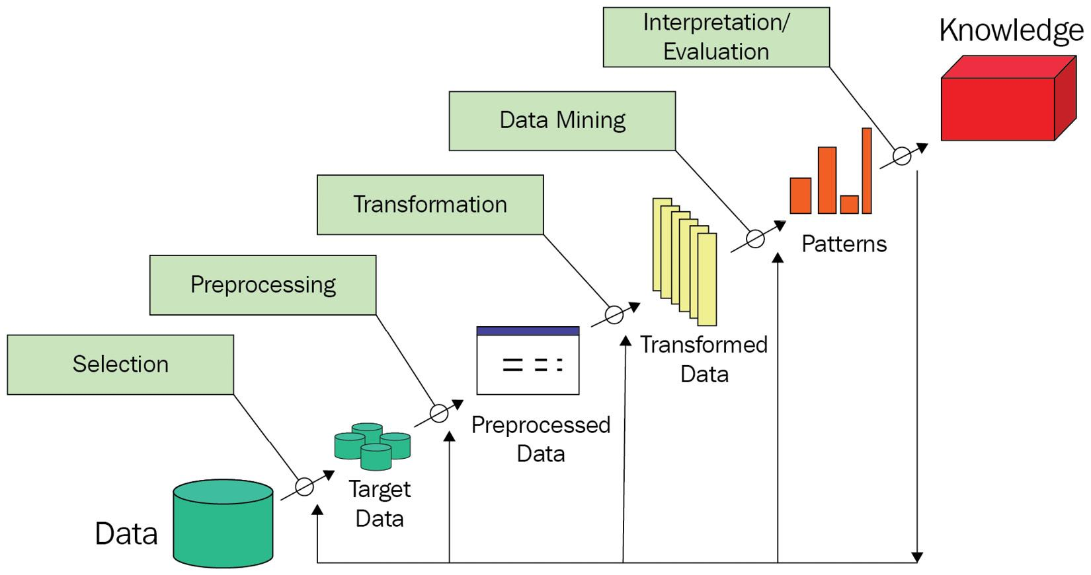
Components
- Database / Data Warehouse Server: Stores integrated patient records.
- Knowledge Base: Stores medical rules, domain knowledge and constraints.
- Data Mining Engine: Performs classification, clustering and prediction.
- Pattern Evaluation Module: Evaluates interestingness and model quality.
- User Interface: Allows doctors and analysts to interact with the system.
4. Classification of the Data Mining System
View | Classification
Kinds of Data | Relational databases, clinical records, laboratory data
Kinds of Knowledge | Classification, association, prediction, clustering
Techniques Used | Decision Trees, Naive Bayes, Logistic Regression
Applications | Healthcare analytics and readmission prediction
5. Data Mining Issues and Mitigation
Issue | Problem | Mitigation
Methodology | Incorrect patient risk factors | Use clinically relevant attributes
User Interaction | Doctors may not understand models | Provide visual dashboards and explanations
Efficiency | Large hospital datasets | Use indexing and scalable algorithms
Diversity of Data | Different medical formats | Standardize and integrate records
Privacy | Sensitive patient information | Encryption and access control
Data Quality | Missing laboratory values | Appropriate imputation and validation
6. Data Mining vs SQL vs Statistics
SQL Query
SQL retrieves records based on predefined conditions.
Example:
SELECT *
FROM Patients
WHERE Readmission = 'Yes';
Statistical Summary
Statistics calculates descriptive measures such as mean, median and standard deviation.
Data Mining
Data mining discovers hidden patterns and relationships.
Example:
A Decision Tree may discover that patients with multiple previous admissions, certain laboratory abnormalities and prolonged stays have higher readmission risk.
SQL retrieves known information, statistics summarizes data, and data mining discovers predictive relationships.
Conclusion
The KDD process enables MediCore to transform integrated patient data into useful knowledge for reducing readmissions.
Q3 – Describing and Comparing Data Dispersion (7 Marks)
1. Given Data
Delivery time of 24 orders in minutes:
28, 31, 33, 35, 35, 36, 38, 40, 41, 42, 42, 43, 45, 46, 48, 50, 52, 53, 55, 58, 61, 64, 72, 95
The data is already sorted.
2. Central Tendency Measures
Mean
\[ Mean=\frac{\sum x}{n} \]
\[ =\frac{1143}{24} \]
\[ \boxed{Mean=47.625} \]
Median
For 24 observations:
\[ Median=\frac{x_{12}+x_{13}}{2} \]
\[ =\frac{43+45}{2} \]
\[ \boxed{Median=44} \]
Mode
35 and 42 occur twice each.
\[ \boxed{Mode=35,\ 42} \]
The distribution is bimodal.
Midrange
\[ Midrange=\frac{Minimum+Maximum}{2} \]
\[ =\frac{28+95}{2} \]
\[ \boxed{Midrange=61.5} \]
Interpretation
Mean (47.625) is greater than median (44). This indicates a positively skewed distribution due to the large delivery time of 95 minutes.
3. Dispersion Measures
Range
\[ Range=Maximum-Minimum \]
\[ =95-28 \]
\[ \boxed{Range=67} \]
Quartiles
Using the median-of-halves convention:
Lower half:
28, 31, 33, 35, 35, 36, 38, 40, 41, 42, 42, 43
\[ Q1=\frac{36+38}{2}=37 \]
Upper half:
45, 46, 48, 50, 52, 53, 55, 58, 61, 64, 72, 95
\[ Q3=\frac{53+55}{2}=54 \]
\[ \boxed{Q1=37,\quad Q3=54} \]
Interquartile Range
\[ IQR=Q3-Q1 \]
\[ =54-37 \]
\[ \boxed{IQR=17} \]
Variance
Using population variance:
\[ \sigma^2=\frac{\sum(x-\bar{x})^2}{n} \]
\[ \boxed{\sigma^2=213.318} \]
Standard Deviation
\[ \sigma=\sqrt{213.318} \]
\[ \boxed{\sigma=14.605} \]
4. Five-Number Summary
Measure | Value
Minimum | 28
Q1 | 37
Median | 44
Q3 | 54
Maximum | 95
Box Plots - Edexcel Maths Revision Guide | MathsGenie
mathsgenie.co.uk
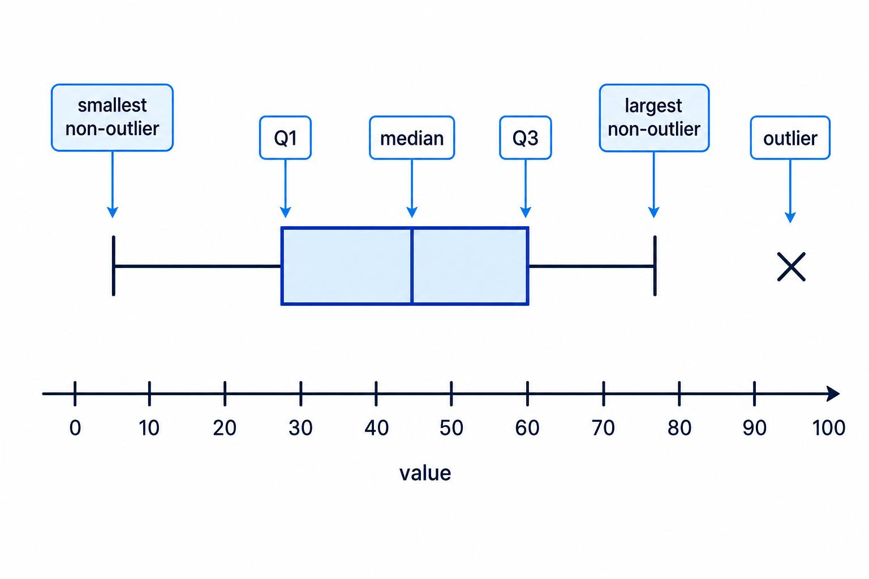
5. Outlier Detection
Using the 1.5 × IQR rule:
\[ LowerFence=Q1-1.5(IQR) \]
\[ =37-25.5=11.5 \]
\[ UpperFence=Q3+1.5(IQR) \]
\[ =54+25.5=79.5 \]
Any value below 11.5 or above 79.5 is an outlier.
Therefore:
\[ \boxed{95\text{ minutes is an outlier}} \]
6. Removing the Largest Value
After removing 95:
Measure | Original | After Removal
Mean | 47.625 | 45.565
Median | 44 | 43
Mode | 35, 42 | 35, 42
Midrange | 61.5 | 50
Range | 67 | 44
Q1 | 37 | 37
Q3 | 54 | 52.5
IQR | 17 | 15.5
Population Variance | 213.318 | 120.767
Population SD | 14.605 | 10.989
The variance, standard deviation, mean and midrange change substantially because they are sensitive to extreme values.
The median and mode are comparatively resistant to outliers.
7. Classification of Measures
Measure | Classification | Explanation
Mean | Algebraic | Can be calculated using count and sum
Median | Holistic | Requires ordered data
Variance | Algebraic | Can be calculated using count, sum and sum of squares
Standard Deviation | Algebraic | Derived from variance
Range | Holistic | Requires global minimum and maximum
- Distributive measures can be computed from partition summaries.
- Algebraic measures require a fixed-size summary of partitions.
- Holistic measures may require all observations or substantial ordering information.
8. Verification Using Python
import numpy as np

x = [28,31,33,35,35,36,38,40,41,42,42,43,
45,46,48,50,52,53,55,58,61,64,72,95]

print("Mean:", np.mean(x))
print("Median:", np.median(x))
print("Variance:", np.var(x))
print("Standard Deviation:", np.std(x))
print("Range:", max(x)-min(x))
print("Q1:", np.percentile(x,25,method="midpoint"))
print("Q3:", np.percentile(x,75,method="midpoint"))
Python can produce different quartiles if a different percentile convention is used.
9. Recommendation
The median is recommended as the typical delivery time because it is resistant to extreme delays.
FreshCart should additionally report:
- Mean delivery time.
- 90th percentile delivery time.
- Percentage of orders delivered within the promised time.
- Number of delayed orders.
This gives customers and management a more realistic picture of delivery performance.
Q4 – Cleaning Noisy and Incomplete Data (6 Marks)
1. Data Quality Defects
Meter | Attribute | Defect | Classification
M102 | kWh | Missing | Missing value
M103 | Region | north instead of North | Inconsistency
M104 | kWh | -14 | Invalid value
M105 | Household Type | Missing | Missing value
M105 | Voltage | 2300 | Noise / invalid value
M106 | Region | S. instead of South | Inconsistency
2. Handling Strategies
Defect | Strategy | Justification
Missing M102 kWh | Attribute mean | Use similar household readings
Missing M105 household type | Most probable value | Infer using household data
north | Standardization | Convert to North
-14 kWh | Investigate / reject | Negative consumption invalid
2300 V | Correct or reject | Likely measurement or decimal error
S. | Standardization | Convert to South
Negative consumption should not automatically be replaced with the mean because it may indicate a meter malfunction or a special operational event.
3. Equal-Frequency Binning
Given values:
5, 9, 11, 14, 18, 19, 23, 26, 27, 30, 33, 38
Depth = 4 bins.
Each bin contains:
\[ 12/4=3\ values \]
Bins
Bin | Values | Mean
B1 | 5, 9, 11 | 8.33
B2 | 14, 18, 19 | 17
B3 | 23, 26, 27 | 25.33
B4 | 30, 33, 38 | 33.67
4. Smoothing by Bin Means
Replace every value in a bin with its bin mean.
Original Bin | Smoothed Values
5, 9, 11 | 8.33, 8.33, 8.33
14, 18, 19 | 17, 17, 17
23, 26, 27 | 25.33, 25.33, 25.33
30, 33, 38 | 33.67, 33.67, 33.67
5. Smoothing by Bin Boundaries
Replace each value with the nearest boundary of its bin.
Bin | Boundaries | Smoothed Values
5, 9, 11 | 5, 11 | 5, 11, 11
14, 18, 19 | 14, 19 | 14, 19, 19
23, 26, 27 | 23, 27 | 23, 27, 27
30, 33, 38 | 30, 38 | 30, 30, 38
6. Regression and Clustering
Regression
Regression predicts the expected value of a sensor reading using other attributes.
For example, voltage, household type and previous readings can be used to estimate missing or noisy kWh values.
Clustering
Clustering groups similar meter readings.
Readings far from their cluster centres may be identified as anomalies.
7. Why 2300 V Is Different from 5 kWh
A value of 2300 V is likely outside the normal voltage range and should be investigated as a measurement error.
A value of 5 kWh may be a valid low consumption reading.
Therefore, unusual values should not automatically be removed. Domain knowledge is needed to distinguish genuine observations from errors.
8. Effect of Global Mean Imputation
Replacing every missing value with the global mean:
- Reduces the variance.
- Makes the distribution less dispersed.
- Creates artificial concentration around the mean.
- Weakens correlations.
- Can distort clustering and classification.
- May hide important subgroups.
Global mean imputation should be avoided when the missingness is systematic or when values differ significantly across classes.
Conclusion
Data cleaning improves data quality and reliability. Binning, regression and clustering help identify noise, but domain knowledge is essential for handling abnormal values correctly.
Q5 – Integration and Transformation of Data (7 Marks)
PART A – Data Integration
1. Source Databases
Admissions Database:
- student_id
- name
- dob
- hostel_status
- scholarship
LMS Database:
- sid
- full_name
- attendance_pct
- marks
- scholarship_flag
2. Integration Conflicts and Resolution
Conflict | Example | Resolution
Entity identification | student_id and sid | Match using common student identifier
Naming conflict | name and full_name | Rename to Student_Name
Attribute conflict | scholarship and scholarship_flag | Merge into Scholarship_Status
Format conflict | Different DOB formats | Convert to YYYY-MM-DD
Value conflict | Hostel / hostel_status | Standardize values
Missing values | Attendance missing | Apply appropriate imputation
3. Integrated Schema
Attribute | Source
Student_ID | Admissions / LMS
Student_Name | Admissions / LMS
DOB | Admissions
Hostel_Status | Admissions
Scholarship_Status | Admissions / LMS
Attendance_Percentage | LMS
Marks | LMS
4. Redundant Attributes
Integration may produce redundant attributes because multiple systems store similar information.
For example:
- Student_Name and Full_Name.
- Scholarship and Scholarship_Flag.
- Student identifiers from different systems.
Correlation analysis and dependency analysis can identify redundant attributes.
PART B – Redundancy Analysis
1. Pearson Correlation Coefficient
Attendance:
60, 70, 75, 80, 85, 90
Marks:
52, 58, 66, 70, 79, 85
Pearson correlation:
\[ r=\frac{\sum(x-\bar{x})(y-\bar{y})} {\sqrt{\sum(x-\bar{x})^2\sum(y-\bar{y})^2}} \]
\[ \boxed{r=0.9851} \]
Interpretation
The correlation coefficient is approximately 0.985.
This indicates a very strong positive linear relationship between attendance percentage and marks.
Students with higher attendance tend to obtain higher marks in this dataset.
2. Chi-Square Test
Observed frequency table:
 | Scholarship | No Scholarship | Total
Hostel | 120 | 180 | 300
Day Scholar | 80 | 320 | 400
Total | 200 | 500 | 700
Expected Frequencies
\[ E=\frac{RowTotal\times ColumnTotal}{GrandTotal} \]
Hostel with scholarship:
\[ E=\frac{300\times200}{700}=85.714 \]
Hostel without scholarship:
\[ E=\frac{300\times500}{700}=214.286 \]
Day scholar with scholarship:
\[ E=\frac{400\times200}{700}=114.286 \]
Day scholar without scholarship:
\[ E=\frac{400\times500}{700}=285.714 \]
Expected Table
 | Scholarship | No Scholarship
Hostel | 85.714 | 214.286
Day Scholar | 114.286 | 285.714
Chi-Square Calculation
\[ \chi^2=\sum\frac{(O-E)^2}{E} \]
\[ \boxed{\chi^2=33.60} \]
Degrees of freedom:
\[ df=(2-1)(2-1)=1 \]
Critical value = 3.84.
Since:
\[ 33.60>3.84 \]
Reject the null hypothesis.
Interpretation
Hostel status and scholarship status are not independent at the 0.05 significance level.
There is a statistically significant association between hostel status and scholarship status in the observed data.
PART C – Data Transformation
1. Min-Max Normalisation
Income values:
₹20,000, ₹35,000, ₹50,000, ₹80,000, ₹150,000
Formula:
\[ X'=\frac{X-Min}{Max-Min} \]
Minimum = 20,000
Maximum = 150,000
Range = 130,000
Income | Min-Max Value
20,000 | 0
35,000 | 0.1154
50,000 | 0.2308
80,000 | 0.4615
150,000 | 1
2. Z-Score Normalisation
\[ Z=\frac{X-\mu}{\sigma} \]
Mean:
\[ \mu=\frac{335000}{5}=67000 \]
Population standard deviation:
\[ \sigma=46000 \]
Income | Z-Score
20,000 | -1.0217
35,000 | -0.6957
50,000 | -0.3696
80,000 | 0.2826
150,000 | 1.8043
3. Decimal Scaling
Formula:
\[ X'=\frac{X}{10^j} \]
Largest absolute value = 150,000.
Choose \(j=6\), because 150000/1000000 = 0.15.
Income | Decimal Scaling
20,000 | 0.020
35,000 | 0.035
50,000 | 0.050
80,000 | 0.080
150,000 | 0.150
4. Euclidean Distance Before Normalisation
Students:
A = (19, 35,000)
B = (21, 80,000)
Formula:
\[ d=\sqrt{(x_2-x_1)^2+(y_2-y_1)^2} \]
\[ d=\sqrt{(21-19)^2+(80000-35000)^2} \]
\[ =\sqrt{4+2025000000} \]
\[ \boxed{d\approx45000.00004} \]
5. Distance After Min-Max Normalisation
Age range = 17–25.
Student A age:
\[ \frac{19-17}{25-17}=0.25 \]
Student B age:
\[ \frac{21-17}{25-17}=0.50 \]
Income range = 20,000–150,000.
Student A income:
\[ \frac{35000-20000}{130000}=0.1154 \]
Student B income:
\[ \frac{80000-20000}{130000}=0.4615 \]
Distance:
\[ d=\sqrt{(0.50-0.25)^2+(0.4615-0.1154)^2} \]
\[ =\sqrt{0.0625+0.1198} \]
\[ \boxed{d\approx0.427} \]
Interpretation
Before normalization, income dominates the distance calculation because it has a much larger numerical scale than age.
After normalization, age and income contribute more comparably.
Normalization is important for distance-based algorithms such as K-Means and KNN.
6. Transformation Examples
Technique | Example
Aggregation | Calculate average marks by department
Generalisation | Convert age into age groups
Attribute Construction | Construct Academic_Performance from Attendance and Marks
Conclusion
Data integration resolves conflicts between different sources. Correlation and chi-square help identify relationships, while normalization improves the quality of distance-based mining.
Q6 – Data Reduction and Discretization (7 Marks)
PART A – Choosing Reduction Strategies
1. Data Reduction Techniques
Technique | Description | Application
Data Cube Aggregation | Summarizes data across dimensions | Hourly sensor readings aggregated daily
Attribute Subset Selection | Removes irrelevant attributes | Select important machine sensor features
PCA | Reduces dimensions using principal components | Reduce 200 sensor attributes
Sampling | Selects representative records | Analyze a subset of 5 million rows
Histograms | Summarizes data distribution | Identify sensor value distributions
Clustering | Represents data using cluster summaries | Group similar machine readings
Compression | Reduces storage requirements | Store large sensor datasets efficiently
2. Attribute Subset Selection
Forward Selection
Start with no attributes and add the most useful attributes.
Backward Elimination
Start with all attributes and remove irrelevant attributes.
Decision Tree Induction
Select attributes based on their importance in predicting machine failure.
3. Sampling Comparison
Sampling | Description | Advantage | Limitation
Without Replacement | Selected records cannot repeat | Unique sample | May miss rare failures
With Replacement | Records may repeat | Useful for bootstrap | Duplicate observations
Cluster Sampling | Select entire clusters | Reduces sampling cost | May produce biased sample
Stratified Sampling | Samples from each class | Preserves class representation | Requires class labels
Recommended Sampling
Only 0.5% of rows represent failures.
Therefore, Stratified Sampling is most appropriate because it preserves failure and non-failure representation.
For classification, oversampling failures or using class weights can further improve performance.
4. PCA Selection
PCA reduces the number of attributes while preserving information.
The number of components should be selected using cumulative explained variance.
For example, retain components that explain approximately 95% of the variance.
The exact number depends on the dataset and should be determined experimentally.
PART B – Discretization by Calculation
Given temperatures:
3, 7, 7, 9, 12, 14, 14, 15, 18, 21, 21, 22, 25, 25, 27, 31, 36, 36, 40, 44
1. Equal-Width Binning
Minimum = 3
Maximum = 44
Number of bins = 4
\[ Width=\frac{44-3}{4} \]
\[ =\frac{41}{4}=10.25 \]
Intervals
Bin | Interval | Values | Count
B1 | 3–13.25 | 3,7,7,9,12 | 5
B2 | 13.25–23.5 | 14,14,15,18,21,21,22 | 7
B3 | 23.5–33.75 | 25,25,27,31 | 4
B4 | 33.75–44 | 36,36,40,44 | 4
Equal-width bins have different numbers of observations.
2. Equal-Frequency Binning
20 values / 4 bins = 5 values per bin.
Bin | Values | Count
B1 | 3, 7, 7, 9, 12 | 5
B2 | 14, 14, 15, 18, 21 | 5
B3 | 21, 22, 25, 25, 27 | 5
B4 | 31, 36, 36, 40, 44 | 5
Equal-frequency binning ensures each bin has approximately the same number of records.
3. Entropy-Based Discretization
Given data:
Value | Class
10 | N
12 | N
15 | N
18 | N
22 | Y
25 | Y
28 | N
31 | Y
35 | Y
40 | Y
There are five N and five Y records.
Initial entropy:
\[ Entropy(S)=1 \]
Formula:
\[ Entropy(S)=-p_N\log_2p_N-p_Y\log_2p_Y \]
Information Gain:
\[ IG=Entropy(S)-Entropy_{weighted} \]
Information Gain Table
Split Point | Information Gain
11 | 0.1080
13.5 | 0.2365
16.5 | 0.3958
20 | 0.6100
23.5 | 0.2781
26.5 | 0.1245
29.5 | 0.3958
33 | 0.2365
37.5 | 0.1080
Best Split
The highest information gain is at:
\[ \boxed{Split=20} \]
This separates the first four N values from the remaining records.
4. Supervised vs Unsupervised Discretization
Unsupervised | Supervised
Does not use class labels | Uses class labels
Equal-width binning | Entropy-based binning
Equal-frequency binning | Information gain
Based on distribution | Based on predictive relevance
Supervised discretization is more appropriate for classification because it selects intervals that help separate target classes.
Conclusion
Data reduction improves computational efficiency while retaining important information. Supervised discretization is especially useful when preparing data for classification models.
Q7 – Diagnose, Redesign and Validate (13 Marks)
A. Diagnose the Computational Bottleneck (2 Marks)
The bank's preprocessing pipeline contains several problems.
Original Step | Defect | Principle Violated | Effect
Global mean income imputation | Ignores income distribution | Appropriate imputation | Reduces variance and distorts relationships
Occupation dropped | 18% missing values | Preserve useful information | Removes potentially important predictor
Equal-width income bins | Income is right-skewed | Appropriate discretization | Most values may fall in a few bins
Normalization before splitting | Uses test-set information | Avoid data leakage | Optimistic and unreliable evaluation
Random 10% sample | Only 3% defaults | Preserve class representation | Too few defaults for training
97% accuracy | Imbalanced classes | Appropriate evaluation metric | Model may predict every loan as non-default
Explanation
If 97% of loans are non-defaults, a model that predicts every loan as non-default achieves 97% accuracy.
However, it detects no actual defaulters.
Therefore, accuracy alone is misleading.
B. Define the Design Objective (2 Marks)
The redesigned pipeline aims to:
- Improve default-class recall.
- Improve F1-score for the default class.
- Maintain acceptable precision.
- Prevent data leakage.
- Preserve important customer attributes.
- Reduce false negatives.
- Maintain reproducibility.
- Support efficient processing of large datasets.
Evaluation Metrics
Metric | Purpose
Accuracy | Overall correct predictions
Precision | Correct predictions among predicted defaults
Recall | Actual defaults detected
F1-score | Balance between precision and recall
ROC-AUC | Ranking ability
PR-AUC | Performance on rare default class
Primary objective: Maximize default recall while maintaining reasonable precision and avoiding excessive false alarms.
C. Design the Revised Preprocessing Strategy (4 Marks)
Revised Pipeline
Hybrid resampling for enhanced multiclass classification | Discover Computing | Springer Nature Link
link.springer.com
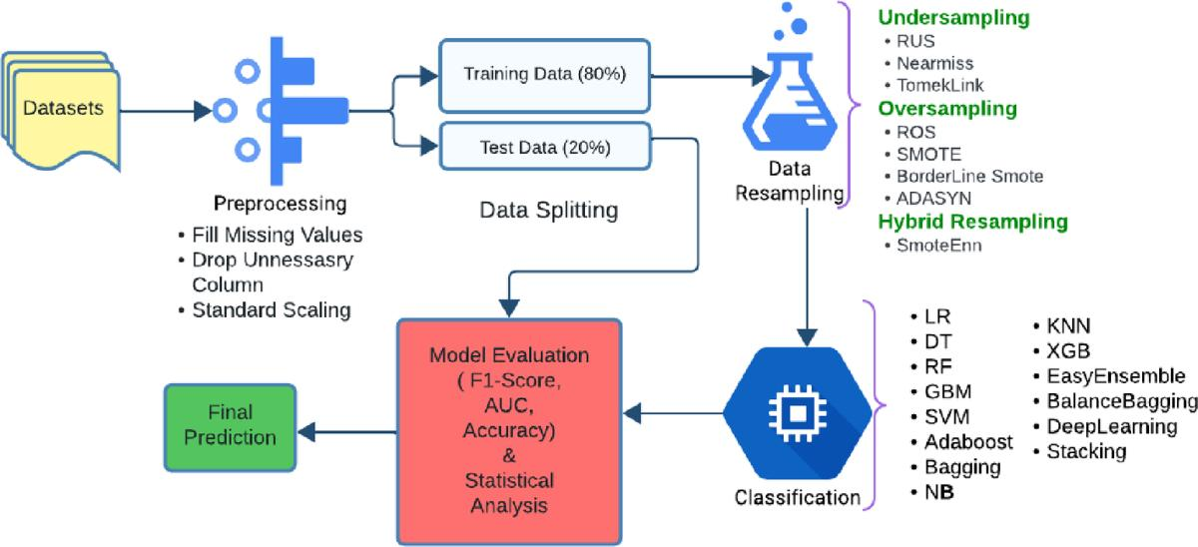
Step 1: Data Selection
Select relevant attributes:
- Income
- Age
- Loan Amount
- Loan Duration
- Occupation
- Credit History
- Employment Status
- Default Label
Remove irrelevant identifiers.
Step 2: Data Cleaning
- Detect duplicate records.
- Correct invalid values.
- Identify missing values.
- Investigate outliers.
- Preserve valid extreme incomes.
Step 3: Handle Missing Income
Income is highly right-skewed.
Use median imputation rather than global mean imputation.
The median is resistant to extreme values.
Compute the median using only the training data.
Step 4: Handle Missing Occupation
Occupation has 18% missing values.
Instead of dropping it:
- Replace missing occupation with "Unknown".
- Create an occupation-missing indicator.
- Retain the original occupation information.
This preserves useful information.
Step 5: Split Dataset
Use stratified splitting.
Example:
- 70% training.
- 30% testing.
The default class proportion should be preserved in both sets.
Step 6: Transformation
- Apply log1p() to highly skewed income.
- Encode categorical variables.
- Normalize numeric variables if required.
- Fit preprocessing transformations on training data only.
- Apply the same transformations to the test data.
Step 7: Class Imbalance Handling
Use:
- Class weights.
- Random oversampling.
- SMOTE applied only to training data.
The test dataset must remain unchanged.
Step 8: Model Training
Candidate models:
- Logistic Regression.
- Decision Tree.
- Random Forest.
Random Forest with class weighting can be evaluated for nonlinear relationships.
Step 9: Evaluation
Evaluate the model using:
- Accuracy
- Precision
- Recall
- F1-score
- ROC-AUC
- Confusion Matrix
- PR-AUC
Choose the classification threshold according to the bank's business costs.
D. Predict Before Implementing (1 Mark)
Before implementing the revised pipeline, the expected changes are:
Measure | Prediction
Income Dispersion | More realistic dispersion preserved
Training Class Distribution | Default representation improved
Accuracy | May decrease
Default Recall | Expected to increase
Default Precision | May decrease
F1-score | Expected to improve if recall and precision balance improves
The redesigned model is expected to identify more defaulters, even if overall accuracy decreases.
E. Implement and Validate the Redesign (2 Marks)
The following Python implementation demonstrates the original and revised pipelines using a synthetic credit dataset with 3% defaults.
The dataset is synthetic for demonstration. Replace it with a public credit dataset for your final experiment.
Python Code
import numpy as np
import pandas as pd

from sklearn.datasets import make_classification
from sklearn.model_selection import train_test_split
from sklearn.impute import SimpleImputer
from sklearn.preprocessing import MinMaxScaler, StandardScaler
from sklearn.pipeline import Pipeline
from sklearn.compose import ColumnTransformer
from sklearn.ensemble import RandomForestClassifier
from sklearn.metrics import classification_report
from sklearn.metrics import confusion_matrix

X, y = make_classification(
n_samples=10000,
n_features=8,
n_informative=5,
n_redundant=1,
weights=[0.97, 0.03],
random_state=42
)

df = pd.DataFrame(X, columns=[
"Income", "Age", "Loan", "Duration",
"Credit", "Employment", "Debt", "History"
])

df["Default"] = y

df.loc[df.sample(frac=0.15, random_state=1).index,
"Income"] = np.nan

# ORIGINAL PIPELINE

X_original = df.drop("Default", axis=1)
y_original = df["Default"]

X_original = X_original.fillna(
X_original["Income"].mean()
)

scaler = MinMaxScaler()

X_original = scaler.fit_transform(X_original)

X_train, X_test, y_train, y_test = train_test_split(
X_original, y_original,
test_size=0.30,
random_state=42
)

original_model = RandomForestClassifier(
random_state=42
)

original_model.fit(X_train, y_train)

original_pred = original_model.predict(X_test)

print("ORIGINAL PIPELINE")
print(classification_report(y_test, original_pred))
print(confusion_matrix(y_test, original_pred))

# REVISED PIPELINE

X = df.drop("Default", axis=1)
y = df["Default"]

X_train, X_test, y_train, y_test = train_test_split(
X, y,
test_size=0.30,
stratify=y,
random_state=42
)

numeric_features = X.columns.tolist()

preprocessor = ColumnTransformer([
("num", Pipeline([
("imputer", SimpleImputer(strategy="median")),
("scaler", StandardScaler())
]), numeric_features)
])

revised_model = Pipeline([
("preprocessor", preprocessor),
("classifier", RandomForestClassifier(
class_weight="balanced",
random_state=42
))
])

revised_model.fit(X_train, y_train)

revised_pred = revised_model.predict(X_test)

print("REVISED PIPELINE")
print(classification_report(y_test, revised_pred))
print(confusion_matrix(y_test, revised_pred))
Validation
Compare both pipelines using the same test dataset.
Metric | Original | Revised
Accuracy | Record output | Record output
Default Precision | Record output | Record output
Default Recall | Record output | Record output
Default F1-score | Record output | Record output
Confusion Matrix | Record output | Record output
The revised model should be judged primarily on default recall and precision rather than accuracy alone.
F. Defend the Final Design (2 Marks)
The revised preprocessing pipeline is more appropriate because it:
- Preserves useful attributes.
- Handles missing values robustly.
- Reduces income skewness.
- Prevents data leakage.
- Preserves class representation.
- Improves detection of rare defaults.
- Uses appropriate evaluation metrics.
Remaining Risk
Even after preprocessing improvements, the model may suffer from:
- Concept drift.
- Changing customer behaviour.
- Incorrect labels.
- Unexpected economic conditions.
- False positive predictions.
The bank should monitor model performance continuously and retrain the model when necessary.
Final Conclusion
The original pipeline failed because it focused on overall accuracy and ignored class imbalance, data leakage and information loss.
The redesigned pipeline uses appropriate cleaning, transformation, stratified splitting, class imbalance handling and evaluation.
This improves the reliability of loan-default prediction and helps the bank identify high-risk customers more effectively.
OVERALL CONCLUSION
Data mining enables organizations to discover useful patterns, identify relationships, detect anomalies and predict future outcomes.
The KDD process provides a systematic approach to data selection, cleaning, transformation, mining and evaluation.
Data dispersion, preprocessing, integration, reduction and discretization are essential for improving data quality and mining performance.
The revised loan-default pipeline demonstrates the importance of avoiding data leakage, handling missing values appropriately and evaluating models using metrics suitable for imbalanced datasets.

